Task 1b - Design Documentation: Wireframes
This document describes the low-fidelity and high-fidelity wireframes for the Greenfield Local Hub web-based ordering platform. The wireframes cover the main screens that the customers and producers will use on the public-facing home page, login and sign up, the customer account dashboard and the producer portal. Each screen is explained in terms of layout, user flow and how it supports the solution’s goals for the cooperative and its users.

Low-fidelity wireframes
Low-fidelity wireframes are made by using simple shapes, placeholder text and minimal styling to show the structure, content hierarchy and key interaction points of the pages. They are mainly used early in the design process to agree on layout and functionality before the visual design and copy are finalised. For Greenfield Local Hub they establish a consistent three-part layout (which is header, main content, footer) and clarify navigation and forms across customer and producer flows.

1. Low-fidelity: Home page
Image: Wireframe Low Fidelity Home Page
Source: Image Below
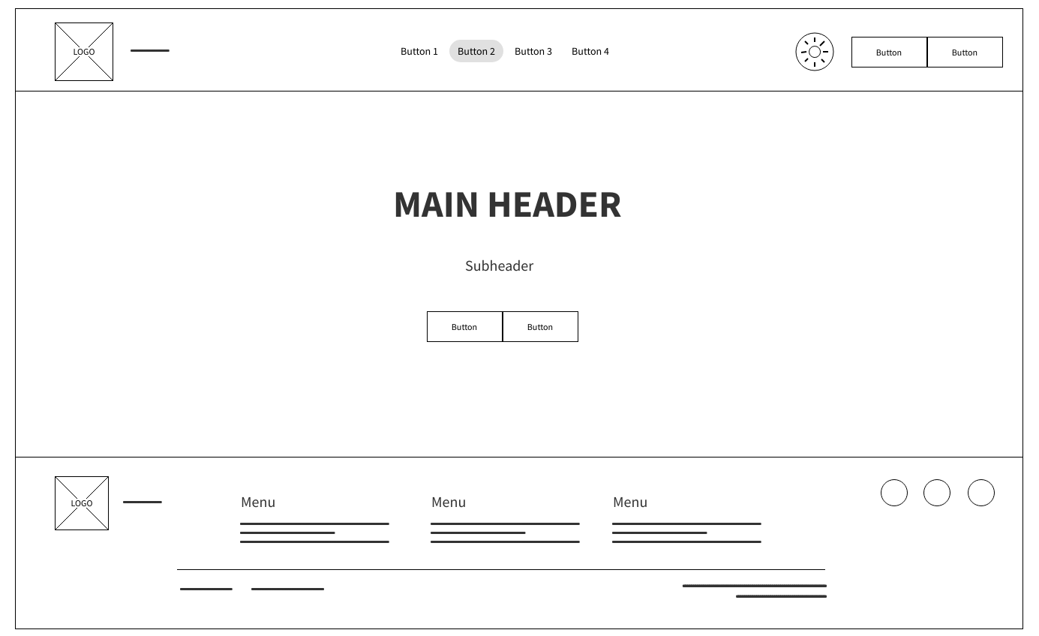
The home page wireframe uses a simple three-section layout where at the top there is a header bar which has a LOGO placeholder on the left, four primary navigation buttons in the centre (with one highlighted to show the current active page) and on the right a circular icon (which is a theme toggle button to change to light or dark or system) plus two buttons for user actions such as Login and Sign Up. The main content area on this wireframe is dominated by a large MAIN HEADER with a Subheader beneath it and two call-to-action buttons below that so new visitors will immediately see the main message and where to go next (e.g. Learn more or Get started). The footer then repeats the logo, three Menu groups (each with link placeholders) and three circular placeholders at the right side for social or external links.
For Greenfield Local Hub this layout supports the proposal’s aim to present the cooperative clearly and guide users. The main header and CTAs (call to actions) communicate what the platform offers and direct people to browse, create an account or sign in. The four main nav buttons define the main sections of the site (e.g. Home, Shop, About, Contact) and the highlighted state shows the user which section the user is in. The footer keeps secondary navigation and legal links (e.g. privacy, terms) available without cluttering the main content. So overall, keeping the structure simple at low fidelity makes it easy to review and change before adding branding and real copy, and the same header and footer pattern is reused across the other wireframes for consistency.

2. Low-fidelity: Login page
Image: Wireframe Low Fidelity Login Page
Source: Image Below
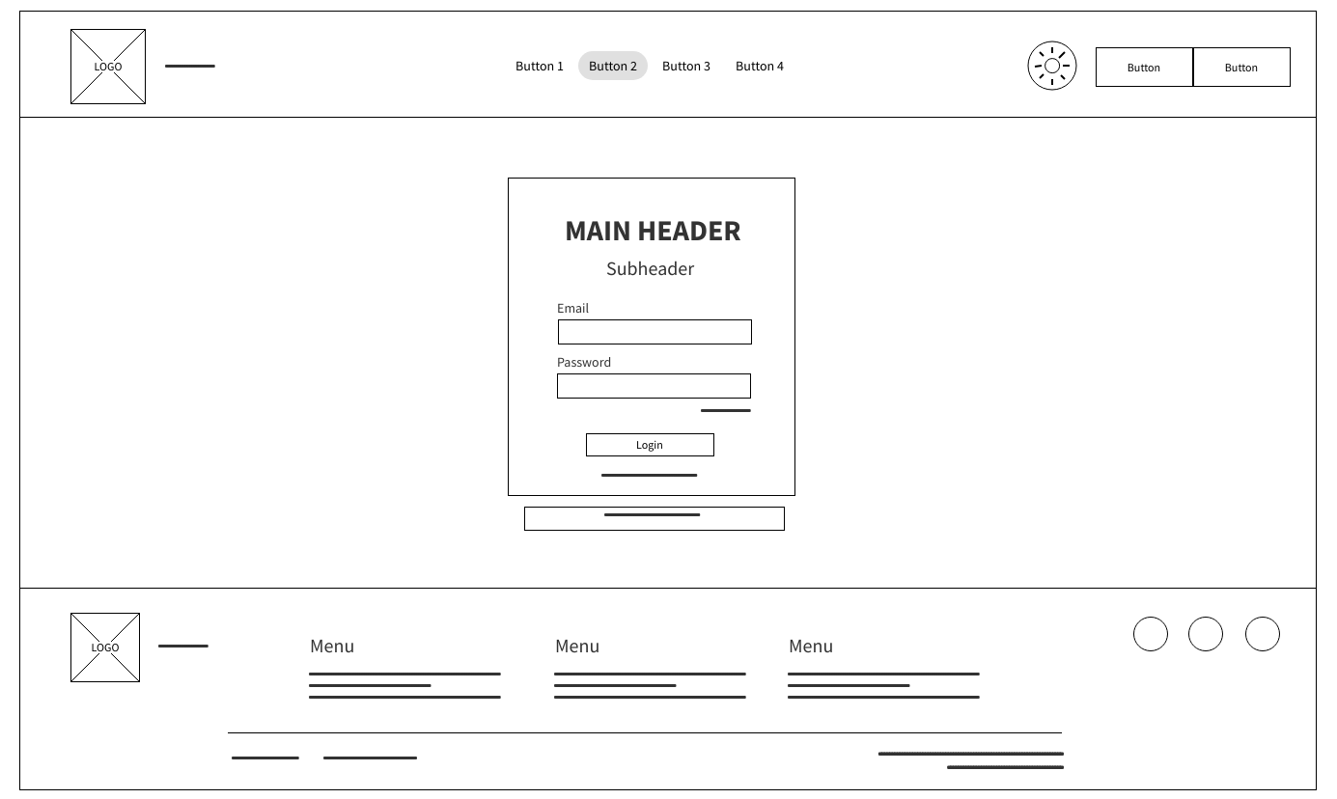
The login page keeps the same header and footer as the home page. The header has the LOGO, the four primary navigation buttons (with one highlighted) and the utility icon plus two buttons on the right. The main content is a single central module containing a MAIN HEADER and Subheader (e.g. Log in to your account), two labelled input fields (Email and Password), a Login button and below it two short line placeholders for links such as Forgot password and Sign Up. A longer line at the bottom of the module can represent terms or help text.
This layout focuses the user on one task which is entering credentials and submitting them. The central form, clear labels and single primary button to reduce confusion and support accessibility (e.g. clear labels for screen readers and keyboard-only use). The link placeholders cover common login needs which are password recovery and moving to sign up. For Greenfield Local Hub, a simple, uncluttered login page supports both customers and producers who need a quick, secure access to their accounts. By reusing the same header and footer from the home page keeps navigation and branding consistent and makes the transition from public pages to authenticated areas feel similar and not different.

3. Low-fidelity: Sign up page
Image: Wireframe-Low-Fidelity-Signup-Page
Source: Image Below
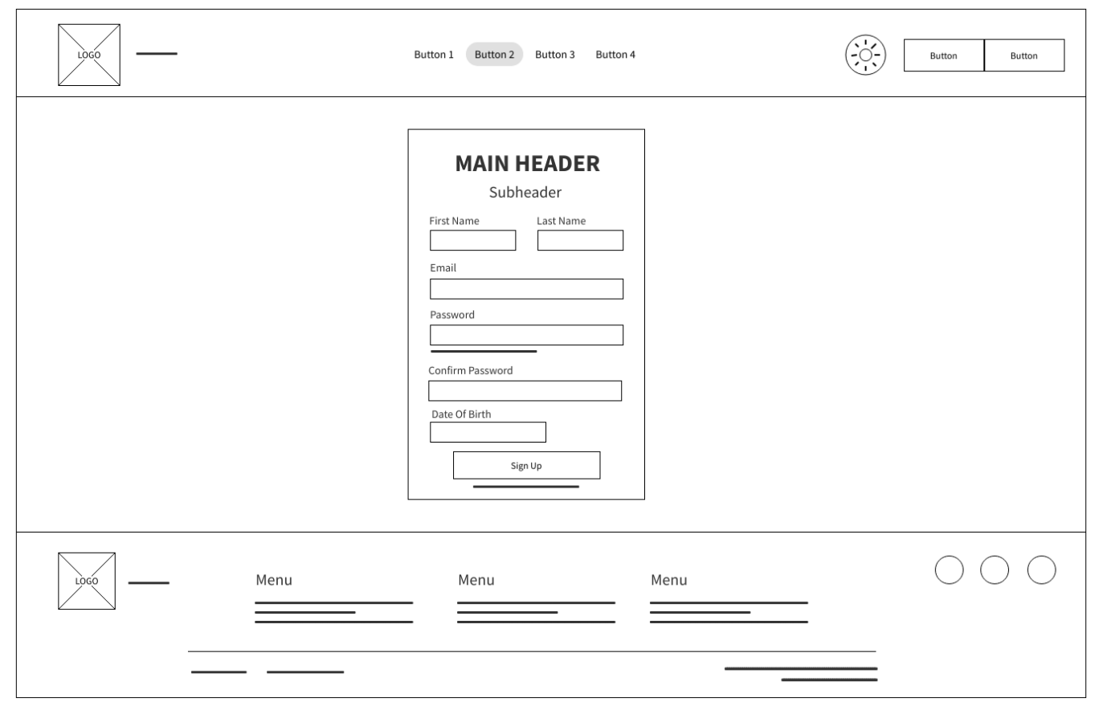
The sign up wireframe again uses the shared header and footer. The header matches the login and home pages (LOGO, four nav buttons, utility icon, two action buttons). The main content is a central form container with MAIN HEADER and Subheader (e.g. Create your account or Join Greenfield Local Hub). The form has six fields which are First Name and Last Name side by side, then a full-width Email, then a Date of Birth and finally Password and Confirm Password input boexs. A single Sign Up button sits below the fields and a short line placeholder beneath it indicates an extra link (e.g. Already have an account? Log in).
Grouping name, email and password in one block with a single submit button keeps the registration flow clear and easy to follow without overcomplicating things. First and last name side by side is a familiar pattern and saves vertical space, email and both password fields full width give enough room for input and any validation messages. For Greenfield Local Hub this supports the proposal’s requirement for customer accounts as the data collected here (name, email, password and date of birth) is what is needed to create an account and later manage orders and preferences especially with the date of birth to ensure that the user that is signing up is over the age of 16 and not a child. The link to log in helps users who already have an account avoid confusion. At low fidelity the wireframe does not show validation rules or password strength as those can be specified in high fidelity or in functional requirements.

4. Low-fidelity: Customer dashboard
Image: Wireframe-Low-Fidelity-Customer-Dashboard
Source: Image Below
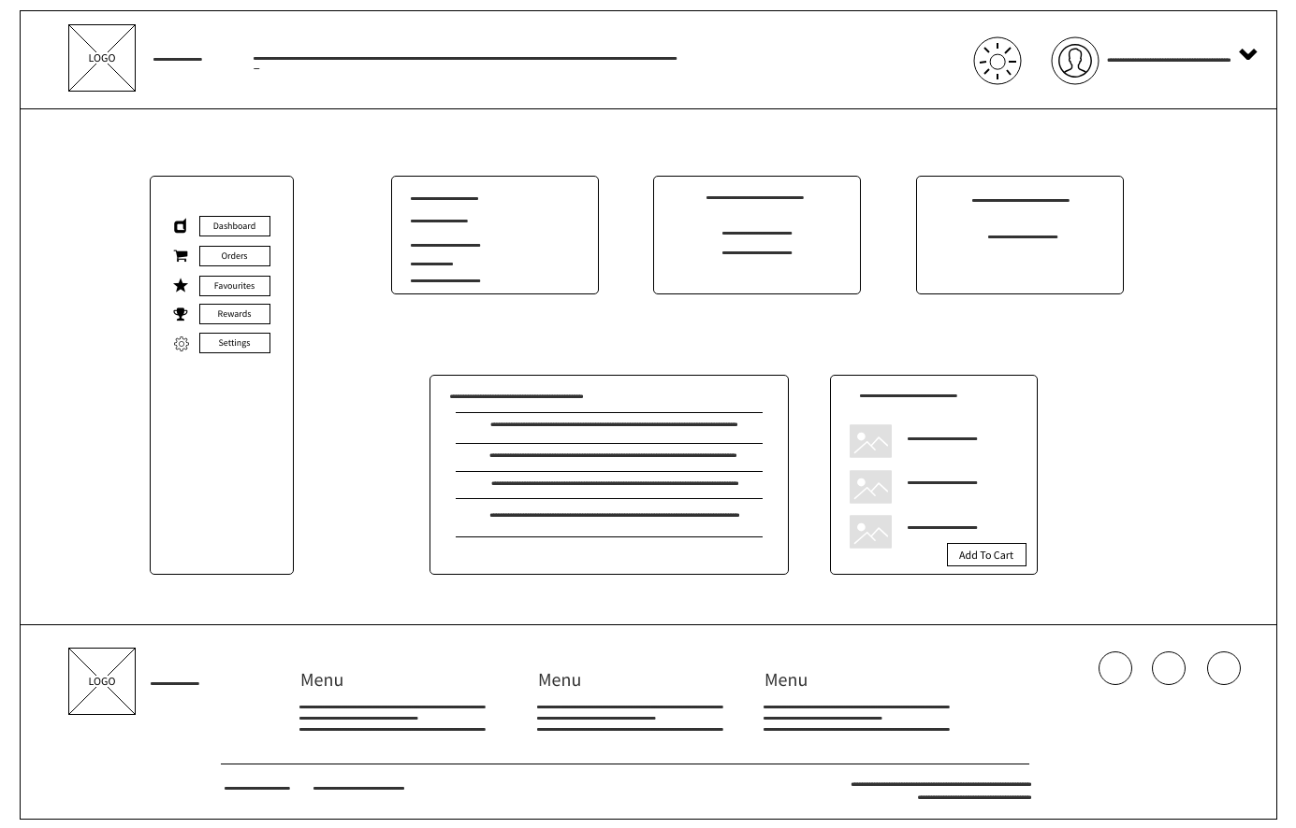
The customer dashboard wireframe introduces a left-hand sidebar in addition to the top header and bottom footer. The header has the LOGO, a longer horizontal line (e.g. search bar), then on the right a sun/theme icon, a user profile icon, a short line (e.g. the users name when theyre logged in) and a dropdown arrow. The sidebar lists five items with icons with the dashboard (e.g. grid icon, active), Orders (cart icon), Favourites (star), Rewards (trophy), Settings (gear). The main content area has a top row of three summary cards which holds stats, then a larger left block with multiple lines of text (e.g. recommendations) and a right block with three small image placeholders, short text lines and an Add to Cart button.
This layout supports the proposal’s customer account features which were order history, reordering and (as an optional extension) favourites and rewards. The sidebar gives quick access to Dashboard, Orders, Favourites, Rewards and Settings so that users will be able to switch pages without losing their place. The summary cards give an at-a-glance overview (e.g. next delivery, loyalty balance). The product block with Add to Cart ties the dashboard to the core e-commerce flow which is that customers can see suggested or recent items and add them to the basket without leaving the dashboard. For difference, the wireframe shows a clear split between navigation (sidebar), overview (cards) and actionable content (product list and CTA), which supports both usability and the stated KPIs around order placement and reordering.

5. Low-fidelity: Producer dashboard
Image: Wireframe-Low-Fidelity-Producer-Dashboard
Source: Image Below
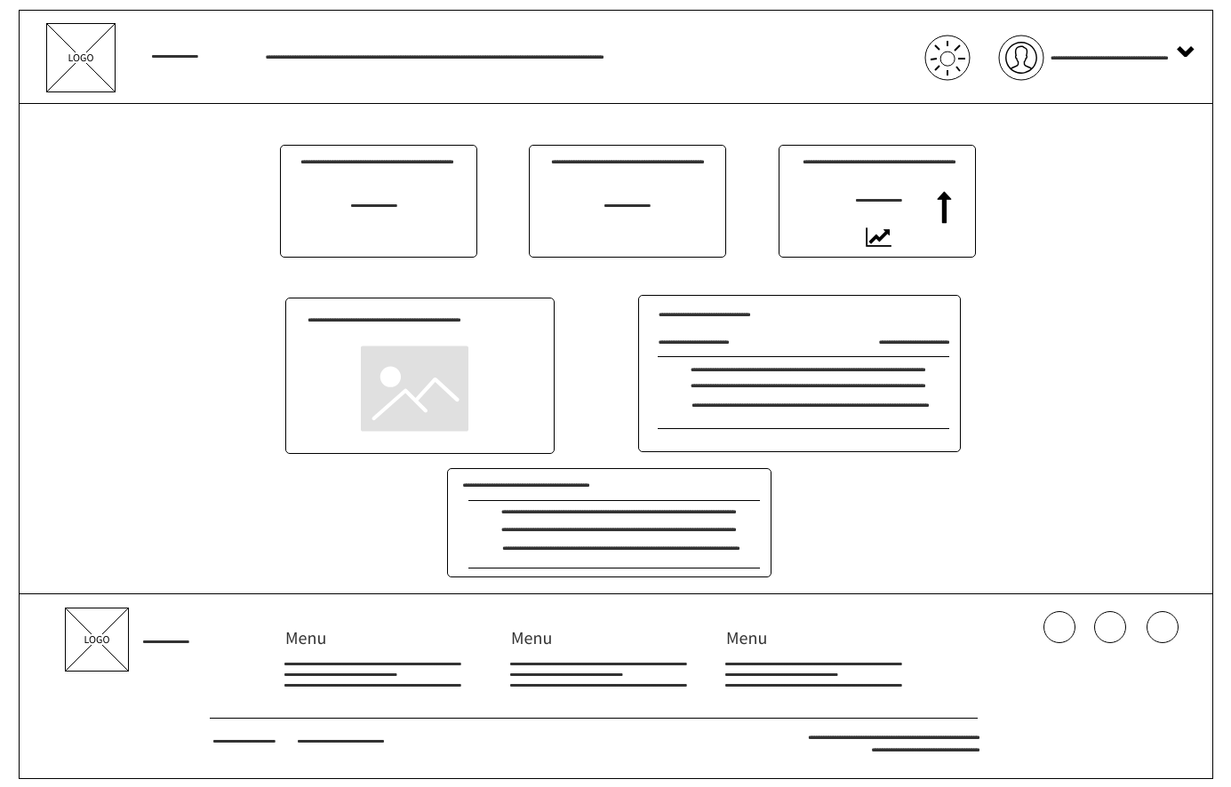
The producer dashboard wireframe uses the same overall structure as the customer dashboard (header, main content, footer) but the main content is a grid of cards rather than a sidebar layout. The header has LOGO, a long line (search or nav), then the theme icon, profile icon and user/dropdown area. The main area has a top row of three cards with one that has several text lines (e.g. notifications or quick stats), two with fewer lines (e.g. metrics). The middle row has a large left card with a title and an image placeholder (e.g. featured content or banner) and a right card with a title and multiple text lines (e.g. summary or article). A central card below has a title and more text lines (e.g. updates or another content block). The footer repeats the logo, three Menu groups and three circular social/external link placeholders.
For Greenfield Local Hub this layout supports the producer dashboard described in the proposal which has a single place for producers to see orders, stock and performance. The top cards can show KPIs such as orders to prepare, products in stock and sales and the middle and lower cards can show charts, low-stock alerts and today’s orders. The wireframe does not spell out every widget but establishes a modular, card-based structure that can scale to orders, inventory, sales trends and alerts. Keeping it low fidelity here allows the GLH team to agree on which blocks appear and where before adding real data and visuals. The absence of a sidebar (compared with the customer dashboard) reflects a different user need as producers need an overview and drill-down into orders and stock rather than a fixed set of account sections, so a grid of widgets is more appropriate.

High-fidelity wireframes
High-fidelity wireframes add colour, typography, realistic copy and recognisable UI elements so the design is close to the final product. They are used to validate layout and content with stakeholders and to hand over to development. For Greenfield Local Hub the high-fidelity set uses a light green and darker green palette and the barn/farm logo to align the UI with the cooperative’s identity and the food and produce sector.

6. High-fidelity: Home page
Image: Wireframe-High-Fidelity-Home-Page
Source: Image Below
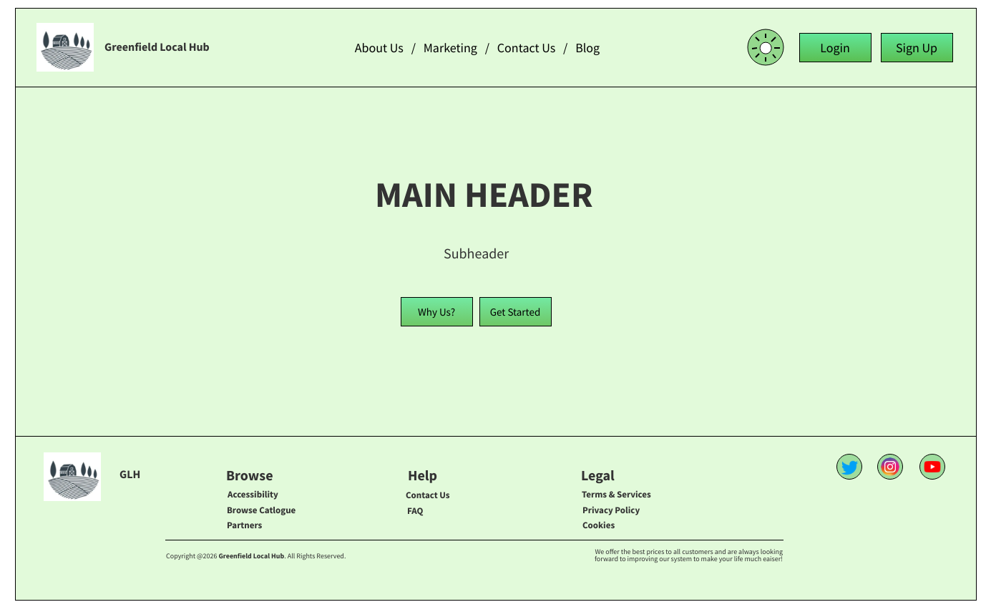
The high-fidelity home page keeps the three-section layout but uses the Greenfield Local Hub branding. The header has the barn-and-fields logo and a short placeholder line for the site name, a centre nav with “About Us / Marketing / Contact Us / Blog”, and on the right the circular settings/theme icon plus two green buttons which are Login and Sign Up. The main content has a bold MAIN HEADER and Subheader, and two green CTA buttons which are “Why Us?” and “Get Started”. The footer repeats the logo, three Menu groups with link placeholders and three social icons (Twitter, Instagram, YouTube) in their brand colours.
The light green background and green buttons give a clear, natural look that fits a local food hub and differentiates the site from generic e-commerce. “Why Us?” and “Get Started” direct new visitors to learn about the cooperative and to register or start shopping, supporting the proposal’s goal of presenting the hub and driving sign-ups and orders. The navigation links at the top (About Us, Marketing, Contact Us, Blog) support trust and transparency between the user and GLH as reusing the same header and footer across high-fidelity screens keeps the experience consistent and reinforces the brand.

7. High-fidelity: Login page
Image: Wireframe-High-Fidelity-Login-Page
Source: Image Below
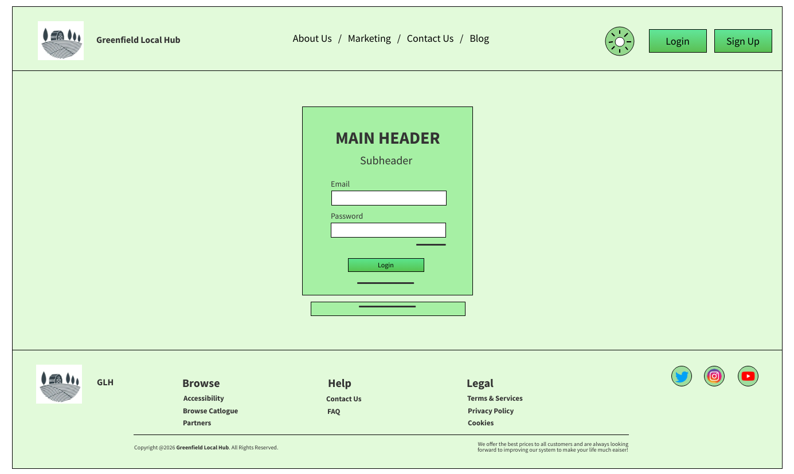
The high-fidelity login page uses the same header and footer as the home page (logo, nav, Login and Sign Up buttons, footer menus and social icons). The main content is a light green panel containing MAIN HEADER and Subheader, two white input fields with “Email” and “Password” labels, a green Login button and two short line placeholders for Forgot password and similar links. A thin horizontal line below the panel suggests a separator or extra link.
The green panel groups the form visually and draws attention to the login action. White input fields contrast with the green background and improve readability. For Greenfield Local Hub this supports secure access for both customers and producers without visual clutter. Now that the Login and Sign Up buttons are clearly shown in the header this means that users can switch to sign up or back to the home page without using the browser back button. Together with the low-fidelity version, this wireframe defines the layout and styling that development and accessibility checks (e.g. focus states, labels) can build on.

8. High-fidelity: Sign up page
Image: Wireframe-High-Fidelity-Signup-Page
Source: Image Below
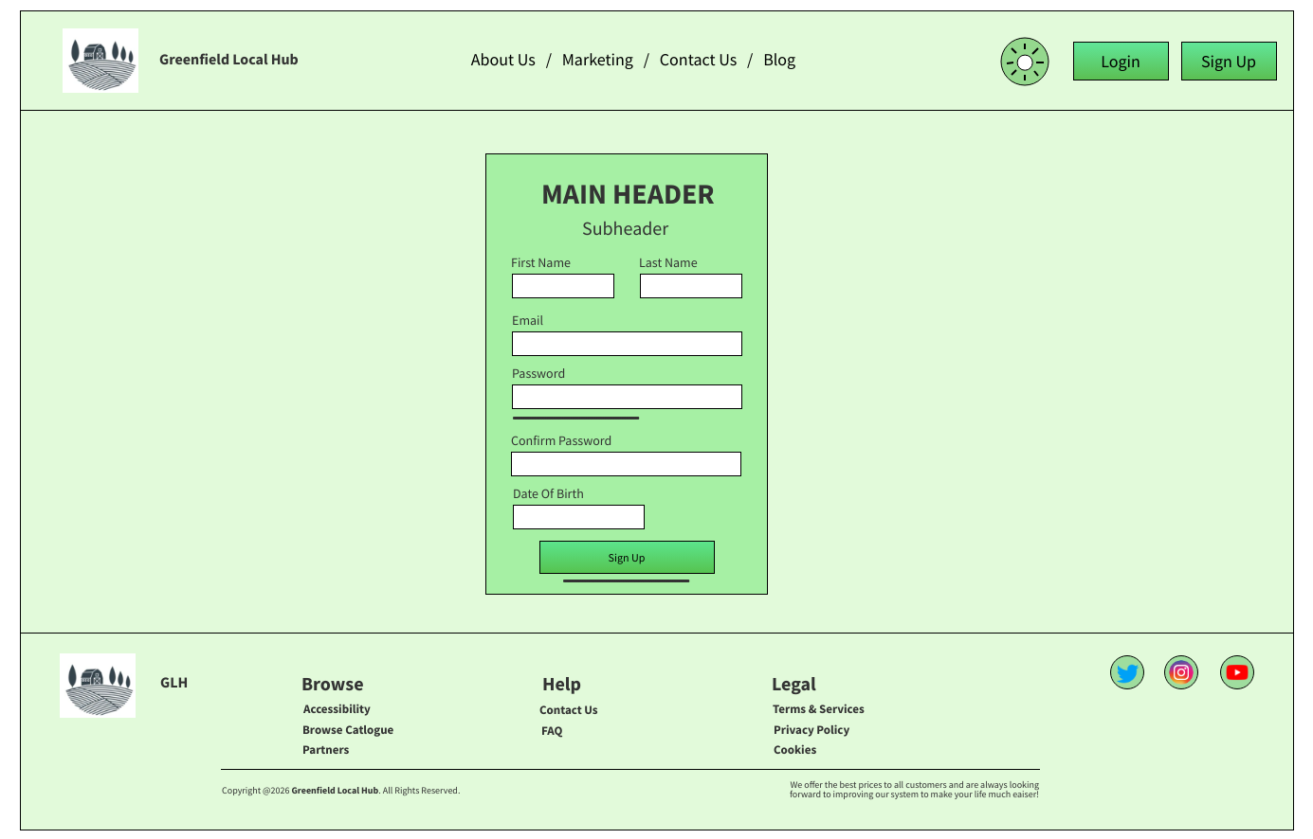
The high-fidelity sign up page mirrors the login structure with a same header (logo, Brand Name, About Us / Marketing / Contact Us / Blog, theme icon, Login and Sign Up) and same footer (logo, three Menus, Twitter, Instagram, YouTube). The main content is a central light green panel with MAIN HEADER and Subheader, then First Name and Last Name side by side, Email, Password and Confirm Password as full-width white fields, and a green Sign Up button. A short line below the button is for a link such as “Already have an account? Log in.”
The layout matches the low-fidelity sign up so that the flow from home to sign up to login is consistent. The green panel and green primary button align with the rest of the site and make the form easy to find. For Greenfield Local Hub the fields align with the data needed for customer accounts (name, email, password and date of birth) and with GDPR and privacy by design so only necessary data is asked for and the privacy notice can be linked from the footer or form. In high fidelity, validation (e.g. password strength, email format and date of birth) and error messages can be added in the next iteration or in the acceptance criteria.

9. High-fidelity: Customer dashboard
Image: Wireframe-High-Fidelity-Customer-Dashboard
Source: Image Below
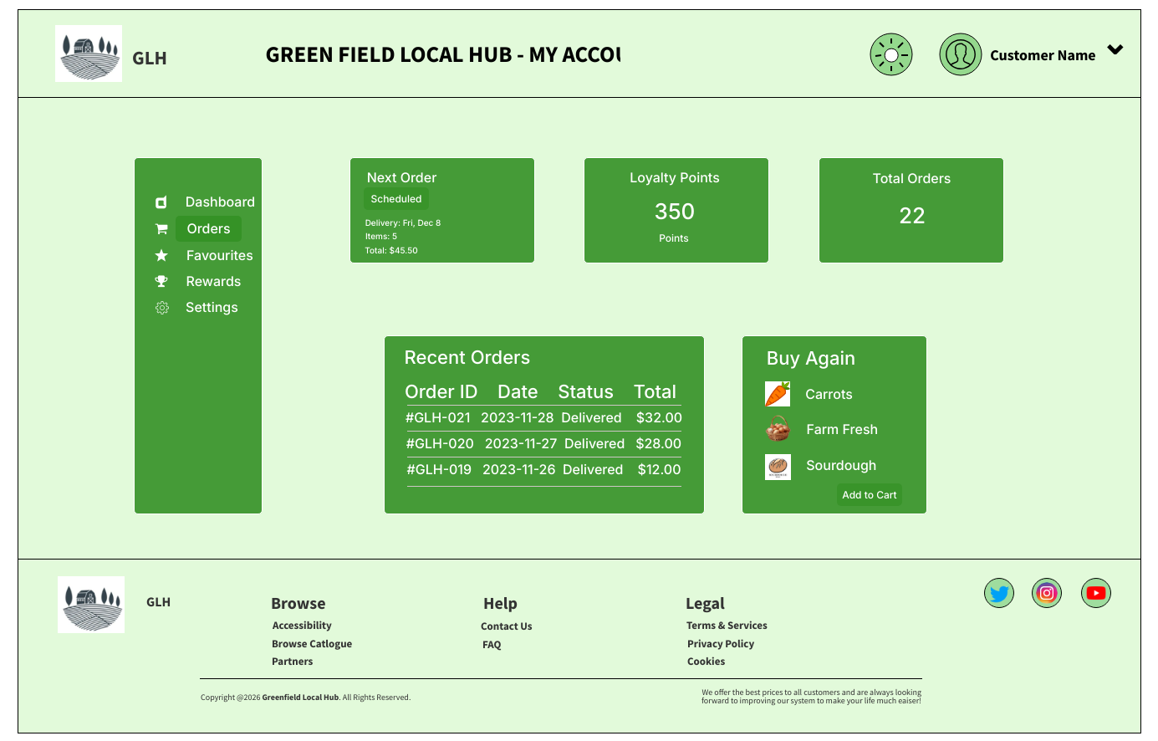
The high-fidelity customer dashboard shows the full customer account experience. The header displays “GREEN FIELD LOCAL HUB - MY ACCOUNT” (or similar) with the barn logo, and on the right the theme icon, profile icon and “Customer Name” with a dropdown. A dark green sidebar on the left lists Dashboard, Orders (highlighted), Favourites, Rewards and Settings with icons. The main content has green cards which are a “Next Order” card (e.g. status Scheduled, delivery date, item count, total), a “Loyalty Points” card (e.g. 350 Points), a “Total Orders” card (e.g. 22), a “Recent Orders” table (Order ID, Date, Status, Total with example rows such as #GLH-021, #GLH-020, #GLH-019) and a “Buy Again” section with three items (e.g. Carrots, Farm Fresh, Sourdough) and an Add to Cart button. The footer repeats the logo, Menu placeholders and social icons.
This wireframe ties the proposal’s customer features to concrete UI. The Next Order and Recent Orders widgets support order tracking and history with the Buy Again and Add to Cart support reordering and the core ordering journey. The Loyalty Points and Rewards entry in the sidebar support the optional loyalty extension. The Orders section being highlighted reflects the dashboard’s role as the main place to see and manage orders which is a key feature that is needing in the final proposal. Using real looking data (order IDs, dates, totals) in the wireframe makes it easier to validate with stakeholders and to define acceptance criteria (e.g. order list loads within a given time, correct status and totals). The dark green sidebar and green cards keep the overall colour pallete theme look consistent with the home, login and sign up screens while making the dashboard clearly an authenticated, account-specific view.

10. High-fidelity: Producer dashboard (Producer portal - Smith Farm)
Image: Wireframe-High-Fidelity-Producer-Dashboard
Source: Image Below
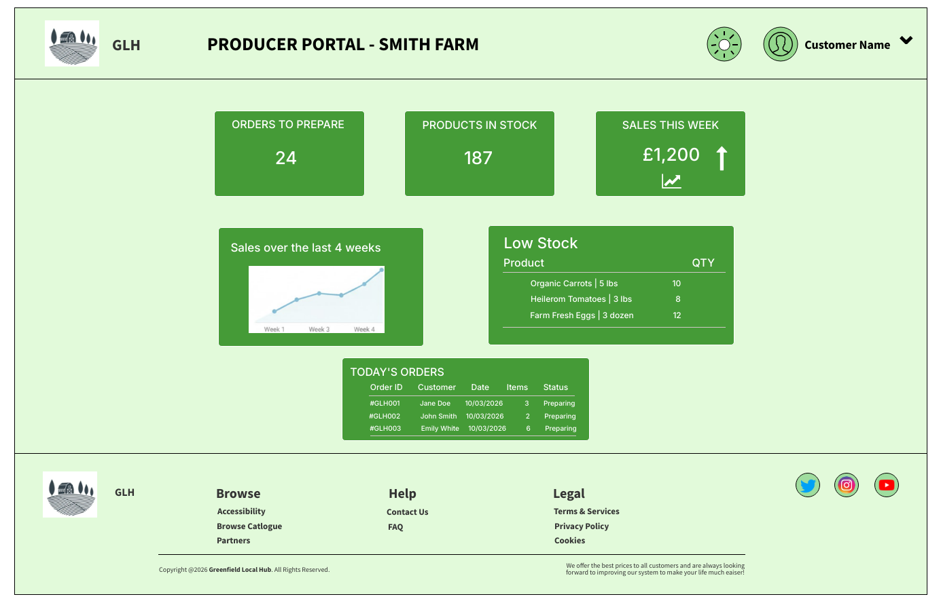
The high-fidelity producer dashboard is titled “PRODUCER PORTAL - SMITH FARM” as an example and uses the same header pattern (barn logo, brand name, theme icon, profile icon, “Customer Name” and dropdown) and footer (logo, Menus, social icons). The main content is a grid of dark green cards on a light green background. The top row has three KPI cards which are “ORDERS TO PREPARE” (e.g. 24), “PRODUCTS IN STOCK” (e.g. 187) and “SALES THIS WEEK” (e.g. £1,200 with an upward arrow and small line graph showing positive correlation). The middle row has “Sales over the last 4 weeks” (line graph, Week 1-4) and a “Low Stock” table with Product and QTY columns (e.g. Organic Carrots, Heirloom Tomatoes, Farm Fresh Eggs with quantities). The bottom row has “TODAY’S ORDERS” with columns Order ID, Customer, Date, Items, Status and example rows (#GLH001 Jane Doe, #GLH002 John Smith, #GLH003 Emily White with status Preparing).
This wireframe implements the producer dashboard from the proposal which is one place where the producers can see orders to prepare, stock levels, sales and low-stock alerts. Orders to Prepare and Today’s Orders support day-to-day fulfilment, Products in Stock and Low Stock support inventory and stock updates, Sales This Week and the four-week graph support which simplifys performance insight. The “Smith Farm” title shows role-based access with each producer sees their own business name and data. For distinction, the wireframe shows how the solution meets producer needs (visibility of orders and stock, basic sales view) without overcomplicating the first release. The card layout is scalable so extra widgets (e.g. product-level sales, alerts) can be added later. The use of dollar amounts and sample data makes it possible to agree on data formats and labels with the client and to write clear acceptance criteria for the producer portal.

Summary
The 10 wireframes above (five low-fidelity and five high-fidelity) show the main page designs for the Greenfield Local Hub platform with home, login, sign up, customer dashboard and producer dashboard pages. The low-fidelity wireframes set a fixed layout, navigation and key elements (forms, sidebars, card grids) so the structure and user flow can be agreed before creating the visual design. The high-fidelity wireframes utilises the cooperative’s green palette and branding which then adds realistic content and widgets so the design is ready for development and testing. Together they show how the proposed solution meets the brief where we have a clear public face (home, login, sign up), customer accounts with order history and reordering (customer dashboard) and a producer view for orders, stock and basic sales (producer dashboard), with room for optional features such as loyalty and rewards. Describing each wireframe in depth in this document supports distinction-level assessment by linking layout and interaction decisions to user needs, the proposal’s core and optional features and the retail (food and produce) context of Greenfield Local Hub.

